**SWINBURNE UNIVERSITY OF TECHNOLOGY**

**COS30045**

**PROJECT STAND-UP 4**

|  |  |  |
| --- | --- | --- |
| **NAME & STUDENTID** | **:** | **Nguyen Gia Binh (104219428)**  **Nguyen Quang Dao - 104211864** |
|  |  |  |
| **CLASS** | **:** | **COS30045** |
| **LECTURER**    **TUTOR** | **:**    **:** | **HOANG XUAN TUNG**  **(**txhoang@swin.edu.au**)**  **HOANG XUAN TUNG**  **(**txhoang@swin.edu.au**)** |

**Hanoi, April 1, 2024**

**TABLE OF CONTENTS**

TABLE OF CONTENTS

**CHAPTER 1: INTRODUCTION**

**CHAPTER 2: CONTRIBUTION ESTIMATION**

2.1: Finding the dataset

2.2: Designing the visualization

2.3: Writing/Researching code

**Chapter 1: INTRODUCTION**

Since the last stand-up we have made significant changes to our project to make sure we follow the teaching staff guidance. We have made significant progress including finalising everything of our design as well as our pre-release visualization. The final product would include 1 geomap of europe territory, a line chart that have some option to view the trend from 2021-2024 and finally the stacked bar chart to show Ukraine IDP demographic.

Mercury link: <https://mercury.swin.edu.au/cos30045/s104219428/Main/index.html>

**Chapter 2: CONTRIBUTION ESTIMATION**

2.1: Finding the dataset

The geomap data is taken from <https://data.unhcr.org/en/situations/ukraine> because they have the most up to date information regarding our topic. For the line chart, the dataset is a little problematic as no one site have the full dataset, eac have just a part of it or some set of the dataset is missing. Nonetheless, the data is taken from [IOM](https://dtm.iom.int/datasets/europe-mixed-migration-flows-europe-yearly-overview-2023), [CEDOS](https://cedos.org.ua/en/researches/forced-migration-and-the-war-in-ukraine-february-24-march-24/), [CEEOL](https://www.ceeol.com/search/viewpdf?id=1207439) and [EuroStat](https://ec.europa.eu/eurostat/statistics-explained/index.php?title=Temporary_protection_for_persons_fleeing_Ukraine_-_monthly_statistics). For the bar chart, it is taken from only 1 source but 2 different report, both are the same report format just in different time [2022](https://dtm.iom.int/reports/ukraine-internal-displacement-report-general-population-survey-round-11-25-november-5), [2024](https://dtm.iom.int/reports/ukraine-area-baseline-assessment-raion-level-round-33-february-2024)

2.2: Designing the visualization

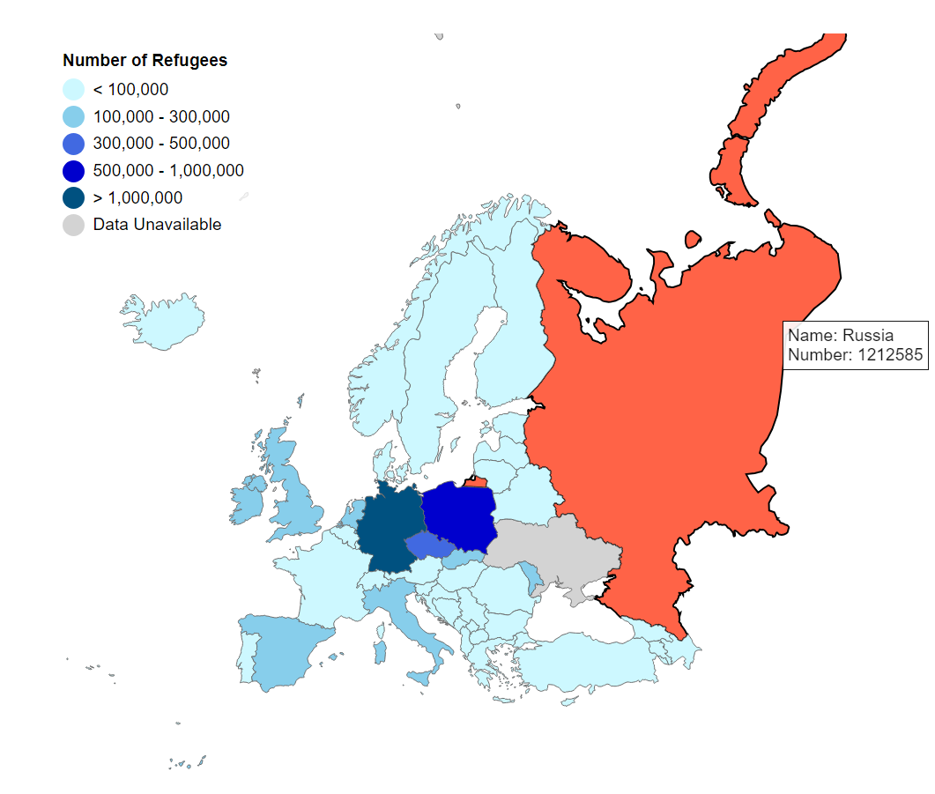

This has been updated and fits into the front-end geomap. The color scheme has been changed to a blue-dominant scheme for a more pleasing aesthetic. Orange is used as the country color on hover, creating a contrast that helps viewers clearly identify each territory. A tooltip with hover functionality has also been added, displaying the latest number of refugees from Ukraine for each country.

Next, the bar chart is a simple one line per chart due to the fact that the recent surge in migration from Ukraine has caused everything else to be clustered if not shown in a single, continuous line. Additionally, there's an option for users to explore the trend for each individual year

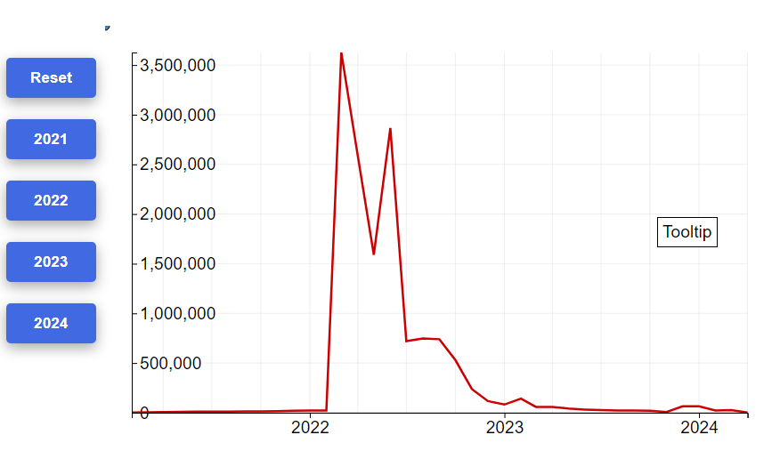

Lastly, the stacked bar chart is a simple, non interactive chart to show the IDP demographic of ukraine during 2022 and 2024 for the purpose of comparing for the most part:

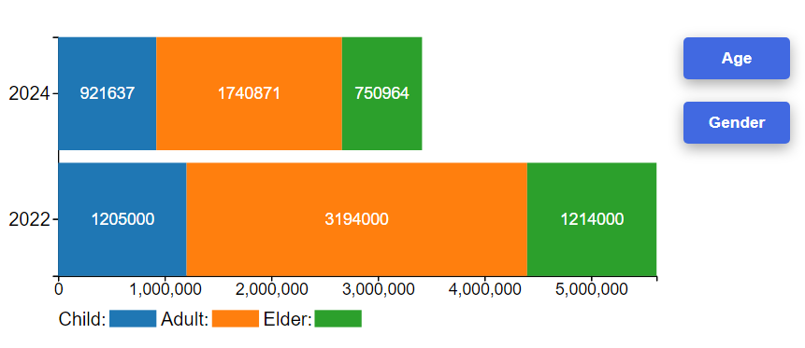

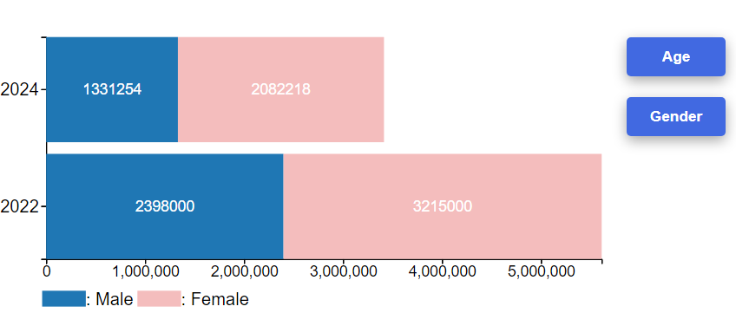

2.3: Writing/Researching code

The geomap code was surprisingly simpler than we expected. The only challenging part was making it fit into the limited space of the front-end design. Europe surprised us with two small and distant territories from the rest of the continent. We decided to hide those since they don't offer any findable data to begin with.

The line chart was very challenging as well since we had to deal with two different situations to handle our data. There are five line charts in total: two lines span from 2021 to now, and four separate lines representing each year. Also, the tooltip of the line chart differs from the geomap tooltip since it needs to be visible all the time to show the closest data point. I ran into the problem of pageX not being properly defined so many times, as well as the clientX and Y dimensions. Another problem I encountered was that the code is very unoptimized. The data format in the default chart, which is the time format, caused the tooltip to not load when run. Further inspection revealed that D3 does not work well with it, and sometimes (it felt random to me) D3 just refused to handle it.

The stacked bar chart was also very problematic. While drawing it wasn't hard (it's all included in Lab 7.3, so no further explanation is needed), the part that I was unable to resolve, which led to the decision of not giving it a tooltip, is related to rectangles (rect elements). Somehow, it seems that when a rectangle is drawn, it can access the data that tells it how long it needs to be (d.data), but after that, it just cannot access it. I tried a number of methods, but then it also struck me that even if I specified which way to calculate (row or column), JavaScript would choose to calculate the key category, which is not the format I want. If I followed through, it would definitely cause confusion to the viewer. This is probably a newbie mistake and such.

In a nutshell, everything is almost done, although there are still some bugs to be fixed.

**Chapter 3: TEAM MATTERS**

We use git hub and it subsequent extension github Desktop to version controling our code. The Dataset is also store on github for convinient

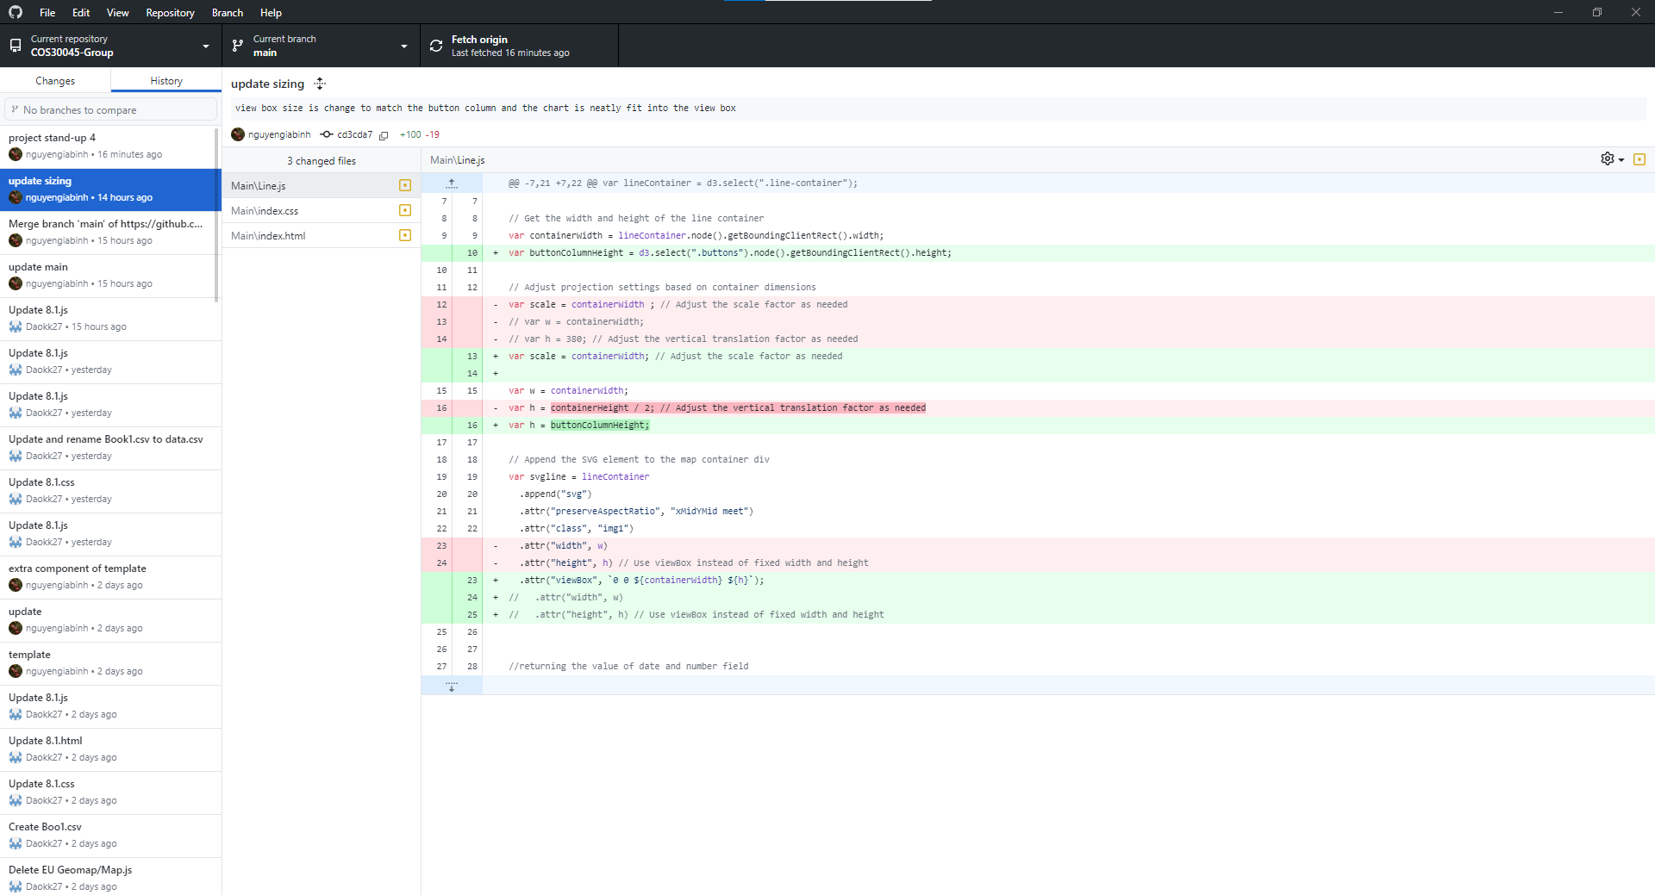

The process book is done on goolge doc but we cant really show it right now since it is not ready